## Basic Functionality of SolidWorks Simulation

Upon successful completion of this lesson, you will be able to understand the basic functionality of SolidWorks Simulation and perform static analysis of the following assembly.

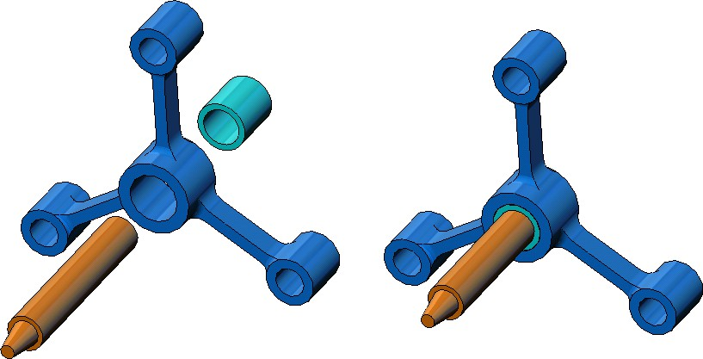

Spider Leg

Hub

Shaft

### Active Learning Exercise — Performing Static Analysis

Use SolidWorks Simulation to perform static analysis on the

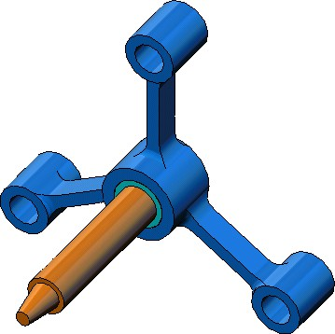Spider.SLDASM assembly shown to the right. The step-by-step instructions are given below.

**Creating a SimulationTemp directory**

We recommend that you save the SolidWorks Simulation Education Examples to a temporary directory to save the original copy for repeated use.

1. Create a temporary directory named SimulationTemp in the Examples folder of the SolidWorks Simulation installation directory.
2. Copy the SolidWorks Simulation Education Examples directory into the

SimulationTemp directory.

**Opening the Spider.SLDASM Document**

1. 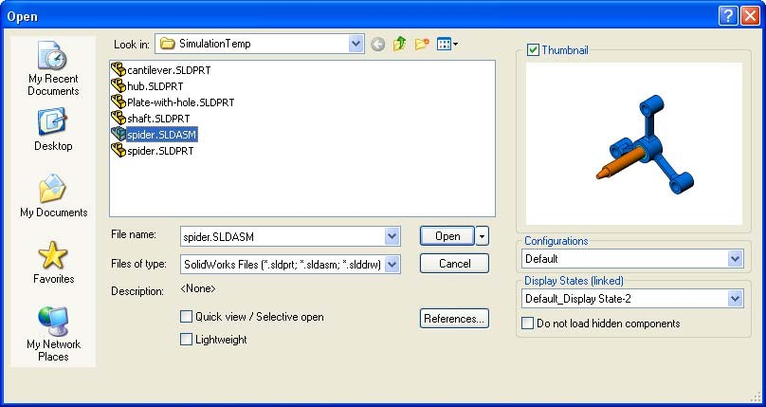Click **Open ** on the Standard toolbar. The **Open** dialog box appears.
2. Navigate to the SimulationTemp folder in the SolidWorks Simulation installation directory.
3. Select Spider.SLDASM
4. Click **Open**.

The spider.SLDASM assembly opens.

The spider assembly has three components: the shaft, hub, and spider leg. The figure below shows the assembly components in exploded view.

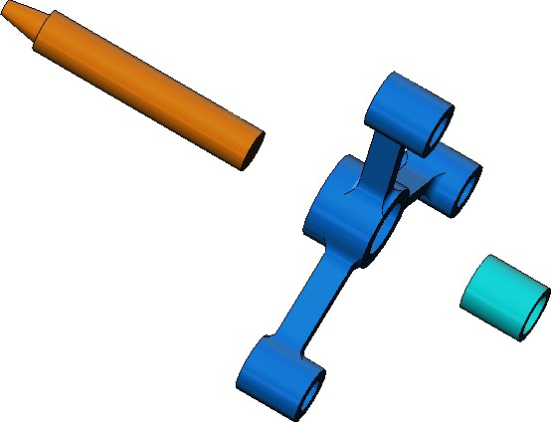

Spider Leg

Shaft

Hub

**Checking the SolidWorks Simulation Menu**

If SolidWorks Simulation is properly installed, the SolidWorks Simulation menu appears on the SolidWorks menu bar. If not:



1. Click **Tools, Add-Ins**.

The **Add-Ins** dialog box appears.

1. Check the checkboxes next to SolidWorks Simulation.

SolidWorks Simulation menu

If SolidWorks Simulation is not in the list, you need to install SolidWorks Simulation.

1. Click **OK**.

The Simulation menu appears on the SolidWorks menu bar.

**Lesson 1: Basic Functionality of SolidWorks Simulation**

**Setting the Analysis Units**

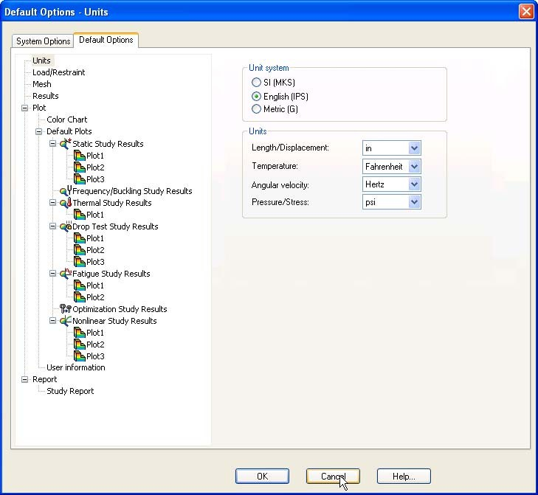Before we start this lesson, we will set the analysis units.

1. On the SolidWorks menu bar click

**Simulation**, **Options**.

1. Click the **Default Options** tab.
2. Select **English (IPS)** under **Unit system.**
3. Select **in** and **psi** from the **Length/ Displacement** and **Pressure/ Stress** fields, respectively.
4. Click **OK**.

**Step 1: Creating a Study**

The first step in performing analysis is to create a study.

1. Click **Simulation**, **Study** in the main SolidWorks menu on the top of the screen. The **Study** PropertyManager appears.
2. 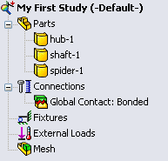Under **Name**, type My First Study.
3. Under **Type**, select **Static**.
4. Click **OK**.

SolidWorks Simulation creates a Simulation study tree located beneath the FeatureManager design tree.

A tab is also created at the bottom of the window for you  to navigate between multiple studies and your model.

**Step 2: Assigning Material**

All assembly components are made of Alloy Steel.

**Assign Alloy Steel to All Components**

1. 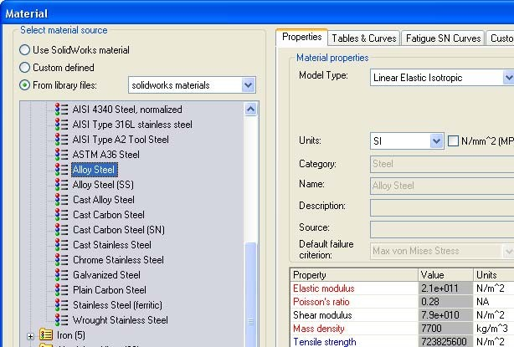In the SolidWorks Simulation Manager tree, right-click the Parts folder and click **Apply Material to All**.

The Material dialog box appears.

1. Under **Select material source**, do the following:
   1. Select **From library files.**
   2. Select

solidworks

materials as material library.

* 1. Click the plus sign next to the **Steel** material category and select **Alloy Steel**.

**Note:** The mechanical and physical properties of Alloy Steel appear in the table to the right.

1. Click **OK**.

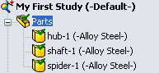Alloy steel is assigned to all components and a check mark appears on each component’s icon. Note that the name of the assigned material appears next to the component’s name.

**Lesson 1: Basic Functionality of SolidWorks Simulation**

**Step 3: Applying Restraints**

We will fix the three holes.

1. 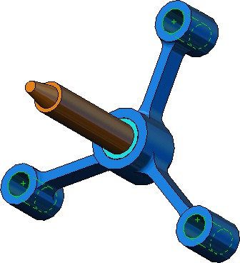Use the **Arrow** keys to rotate the assembly as shown in the figure.
2. In the Simulation study tree, right-click the Fixtures folder and click **Fixed Geometry**.

The **Fixture** PropertyManager appears.

1. Make sure that **Type** is set to **Fixed Geometry**.
2. In the graphics area, click the faces of the three holes, indicated in the figure below.

Face<1>, Face<2>, and Face<3> appear in the **Faces, Edges, Vertices for Fixture** box.

1. Click .

Fixed restraint is applied and its symbols appear on the selected faces.

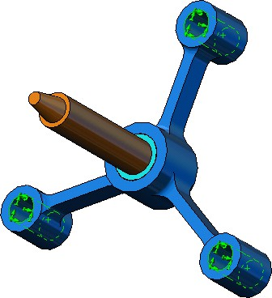

Fixed restraint symbols

Also, Fixture-1 item appears in the Fixtures folder in the Simulation study tree. The name of the restraint can be modified at any time.

**Step 4: Applying Loads**

We will apply a 500 lb force normal to the face shown in the figure.

1. 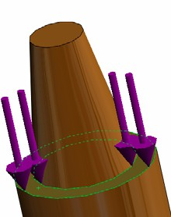Click **Zoom to Area ** icon on the top of the graphics area and zoom into the tapered part of the shaft.
2. In the SolidWorks Simulation Manager tree, right-click the

External Loads folder and select **Force**. The **Force/Torque** PropertyManager appears.

1. In the graphics area, click the face shown in the figure.

Face<1> appears in the **Faces and Shell Edges for Normal Force** list box.

1. Make sure that **Normal** is selected as the direction.
2. Make sure that **Units** is set to **English (IPS)**.
3. In the **Force Value ** box, type **500**.
4. Click .

SolidWorks Simulation applies the force to the selected face and Force-1 item appears in the External Loads folder.

**To Hide Restraints and Loads Symbols**

In the SolidWorks Simulation Manager tree, right-click the Fixtures or External Loads folder and click **Hide All**.

**Step 5: Meshing the Assembly**

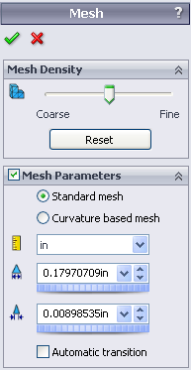Meshing divides your model into smaller pieces called elements. Based on the geometrical dimensions of the model SolidWorks Simulation suggests a default element size (in this case 0.179707 in) which can be changed as needed.

1. In the Simulation study tree, right-click the Mesh icon and select

**Create Mesh**.

The **Mesh** PropertyManager appears.

1. Expand **Mesh Parameters** by selecting the check box.

Make sure that **Standard mesh** is selected and **Automatic transition** is not checked.

Keep default **Global Size ** and **Tolerance **suggested by the program.

1. Click **OK** to begin meshing.

**Lesson 1: Basic Functionality of SolidWorks Simulation**

obal size

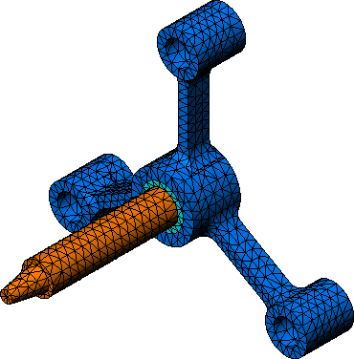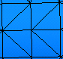

Gl

Global element size is a measure of the average diameter of a sphere circumscribing the element.

**Step 6: Running the Analysis**

In the Simulation study tree, right-click the My First Study icon and click **Run** to start the analysis**.**

When the analysis completes, SolidWorks Simulation automatically creates default result plots stored in the Results folder.

**Step 7: Visualizing the Results**

**von Mises stress**

1. Click the plus sign  beside the Results folder. All the default plots icons appear.

**Note:** If no default plots appear, right-click the Results folder and select

**Define Stress plot.** Set the options in the PropertyManager and click

.



1. Double-click Stress1 (-vonMises-) to display the stress plot.

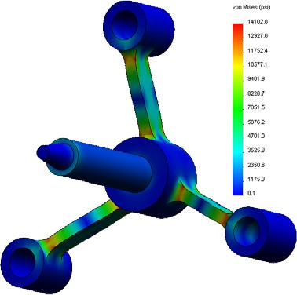

**Note:** To show the annotation indicating the minimum and the maximum values in the plot, double-click the legend and check **Show min**

**Animating the Plot**



**annotation** and **Show max annotation** check boxes. Then click

.

1. Right-click Stress1 (-vonMises-) and click **Animate**.

The **Animation** PropertyManager appears and the animation starts automatically.

1. 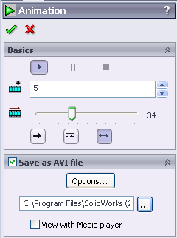Stop the animation by clicking the **Stop** button . The animation must be stopped in order to save the AVI file on the disk.
2. Check **Save as AVI File**, then click  to browse and select a destination folder to save the AVI file.
3. Click  to **Play** the animation.

The animation is played in the graphics area.

1. Click  to **Stop** the animation.
2. Click to close the **Animation** PropertyManager.

**Visualizing Resultant Displacements**

1. 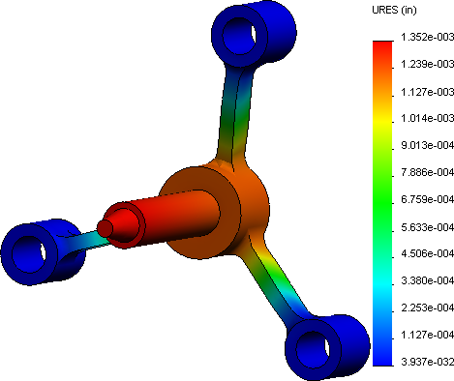Double-click Displacement1

(-Res disp-) icon to display the resultant displacement plot.

**Is the Design Safe?**

The **Design Check Wizard** can help you answer this question. We will use the wizard to estimate the factor of safety at every point in the model. In the process, you will need to select a yielding failure criterion.

1. 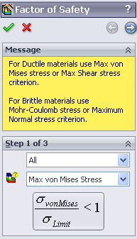Right-click the Results folder and select **Define Factor of Safety Plot. Factor of Safety**wizard **Step 1 of 3** PropertyManager appears.
2. Under **Criterion **, click **Max von Mises stress**.

**Note:** Several yielding criteria are available. The von Mises criterion is commonly used to check the yielding failure of ductile materials.

1. Click **Next**.

**Lesson 1: Basic Functionality of SolidWorks Simulation**

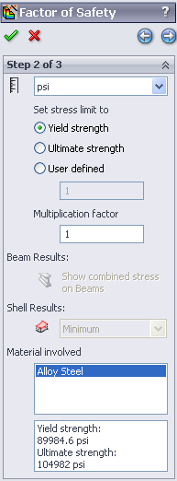**Design Check** wizard **Step 2 of 3** PropertyManager appears.

1. Set **Units **to **psi**.
2. Under **Set stress limit to**, select **Yield strength.**

**Note:** When material yields, it continues to deform plastically at a quicker rate. In extreme case it may continue to deform even if the load is not increased.

1. Click  **Next.**

**Design Check** wizard **Step 3 of 3** PropertyManager appears.

1. Select **Areas below factor of safety** and enter **1**.
2. Click to generate the plot.

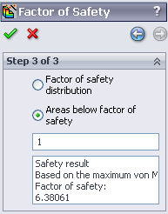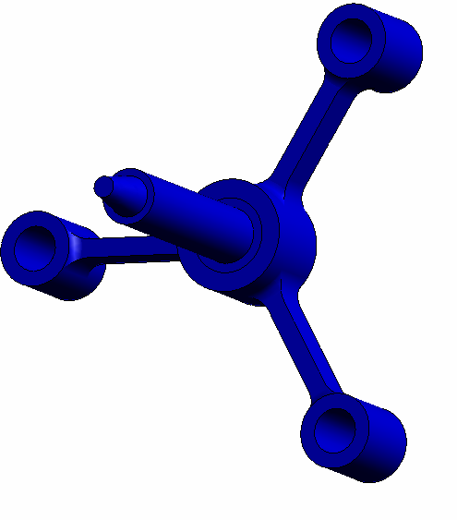

Inspect the model and look for unsafe areas shown in red color. It can be observed that the plot is free from the red color indicating that all locations are safe.

**Lesson 1: Basic Functionality of SolidWorks Simulation**

**How Safe is the Design?**

1. 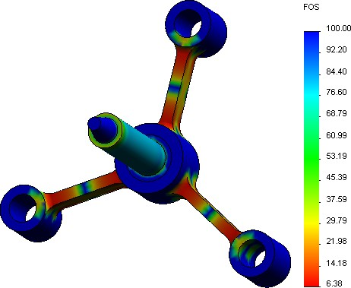Right-click the Results folder and select **Define Design Check Plot.**

**Design Check** wizard **Step 1 of 3**

PropertyManager appears.

1. In the **Criterion** list, select **Max von Mises stress**.
2. Click **Next**.

**Design Check** wizard **Step 2 of 3**

PropertyManager appears.

1. Click **Next.**

**Design Check** wizard **Step 3 of 3**

PropertyManager appears.

1. Under **Plot results**, click **Factor of safety distribution**.
2. Click .

The generated plot shows the distribution of the factor of safety. The smallest factor of safety is approximately 6.4.

**Note:** A factor of safety of 1.0 at a location means that the material is just starting to yield. A factor of safety of 2.0, for example, means that the design is safe at that location and that the material will start yielding if you double the loads.

**Saving All Generated Plots**

1. Right-click My First Study icon and click **Save all plots as JPEG files**. The **Browse for Folder** window appears.
2. Browse to the directory where you want to save all result plots.
3. Click **OK**.

**Generating a Study Report**

The **Report** utility helps you document your work quickly and systematically for each study. The program generates structured Internet-ready reports (HTML files) and Word documents that describe all aspects related to the study.

1. Click **Simulation**, **Report** in the main SolidWorks menu on the top of the screen.

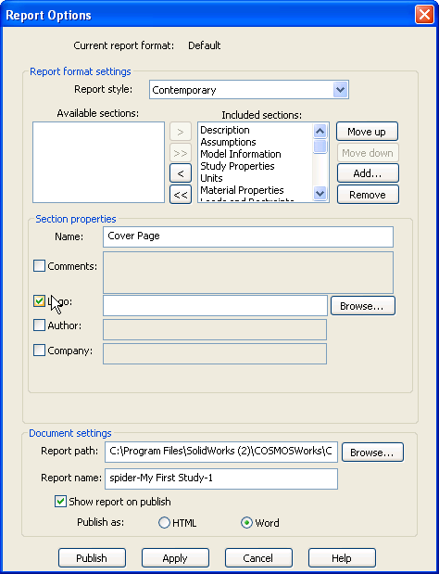The **Report Options** dialog box appears.

The **Report format settings** section allows you to select a report style and choose sections that will be included in the generated report. You may exclude some of the sections by moving them from the **Included sections** field to the **Available** field.

1. Each report section can be customized. For example, select the **Cover Page** section under **Included sections** and fill the **Name, Logo, Author** and the **Company** fields.

Note that the acceptable formats for the logo files are **JPEG Files (*.jpg), GIF Files (*.gif)**, or **Bitmap Files (*.bmp)**.

1. Highlight **Conclusion** in the **Included Sections** list and enter conclusion of your study in the **Comments** box.
2. Select the **Show report on Publish** check box and the **Word** option.
3. Click **Publish**.

The report opens in your word document.

Also, the program creates an icon  in the Report folder in the SolidWorks Simulation Manager tree.

To edit any section of the report, right-click the report icon and click **Edit Definition**. Modify the section and click **OK** to replace the existing report.

**Step 8: Save Your Work and Exit SolidWorks**

1. Click  on the Standard toolbar or click **File, Save**.
2. Click **File, Exit** on the main menu

### Deflection of a Beam Due to an End Force

Some simple problems have exact answers. One of these problems is a beam loaded by force at its tip as shown in the figure. We will use SolidWorks Simulation to solve this problem and compare its results with the exact solution.

**Tasks**

1. Open the Front_Cantilever.sldprt file located in the Examples folder of the SolidWorks Simulation installation directory.

100 lb force

Fixed face L=10 in

w=1 in

h=1 in

cross-section

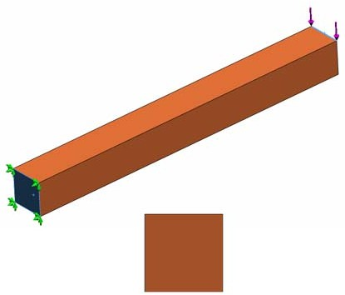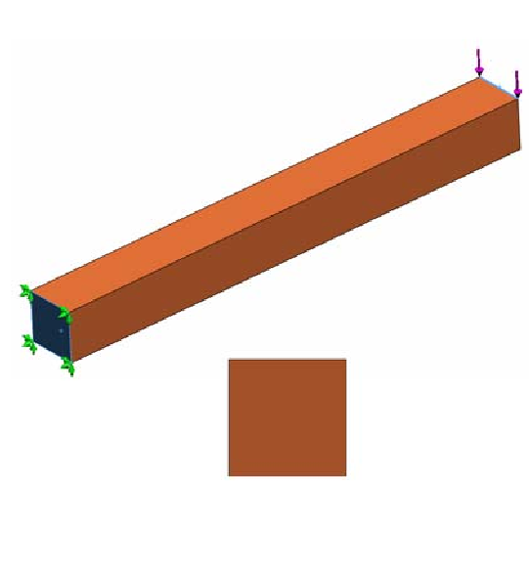

100 lb force

Fixed face

L=10 in

w=1in

h=1in

cross-section

1. Measure the width, height, and length of the cantilever.
2. Save the part to another name.
3. Create a **Static** study.
4. Assign **Alloy Steel** to the part. What is the value of the elastic modulus in psi?

**Answer: 30457924.91**

1. Fix one of the end faces of the cantilever.
2. Apply a downward force to the upper edge of the other end face with magnitude of **100 lb**.
3. Mesh the part and run the analysis.
4. Plot the displacement in the Y-direction. What is the maximum Y-displacement at the free end of the cantilever?

**Answer: 1.31 x10^2**

1. Calculate the theoretical vertical displacement at the free end using the following formula:

*UYTheory* =

3

-------------

4*FL*

*Ewh*3

where *F* is the force, *L* is the length of the beam, *E* is the modulus of elasticity, *w* and *h*

are the width and height of the beam, respectively.

**Answer:1.31x10^-3**

1. Calculate the error in the vertical displacement using the following formula:

 *UYTheory* – *UYCOSMOS*

*ErrorPercentage* =

 

- 100

*UYTheory*

**Answer: 9.035% for maximum**